MANAGING CUSTOM OPPORTUNITIES

Managing Custom Opportunities in CRM is a procedure for creating working records of programs offered to custom clients at Wharton Executive Education.

Following the steps described below enables you to record a new Executive Education program and manage its development from the starting point to its project completion.

Listed here are the broad steps you follow during the various phases of the project:

- Open web version of CRM
- Create the new Opportunity by filling in the Summary section, Custom Program Definition, Forecast Information, and Description.
- Fill in the “Custom Program Definition” section with details of the program and with pricing information when it can be determined.
- Track emails, phone calls, etc. on the Opportunity and add notes while it is still in the negotiations stage.
- Manage the Opportunity as a Project once the contract has been won.

For new clients and/or new programs with existing clients, the Business Development Director is responsible for entering these into CRM. For renewal programs, the PDM Director is responsible for entering into CRM.

To begin, click on desktop icon for Microsoft Dynamics CRM. If you do not have it, contact IT.

On the top of the screen, there is a navy blue ribbon. On the left side, click on “Sales” and another ribbon will pop up. Click on “Opportunities.”

When you do this, you are brought into the “Opportunities” display screen. You can create a new “Opportunity” by clicking on the “New” tab at the top left-hand side of your search screen. If you don’t see the “New” option, click on the “Opportunities” tab in the ribbon at the top and the bar will display showing the “New” tab.

Part 1: Creating the New Opportunity record

When you click on “New”, you get the following screen displayed:

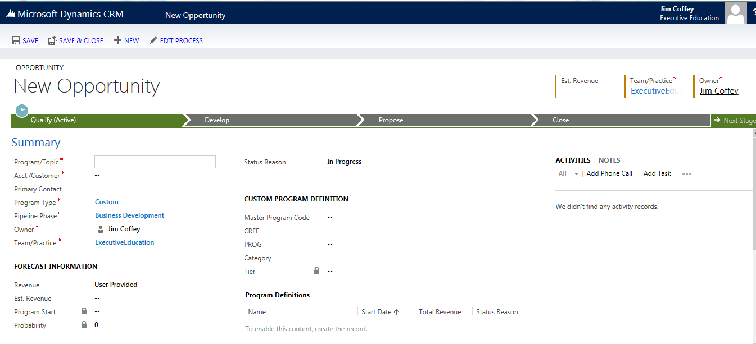

- The “New” screen is composed of the following blocks of data:
- Summary
- Custom Program Definition
- Forecast Information
- Description
- Administrative

- To fill in the “Summary section:
- Note the red asterisks – these are the required fields.
- Note also the required fields filled in
- Always when searching, use asterisks to locate the name of an Account, Contact, Opportunity, etc. This will avoid creating duplicate records. (e.g.: for a common name such as Margie Wilson, you could type *m*Wils*).
- Any field with a “lock” picture means you cannot change it because it is either a calculation or derived from another field you’ve already completed

- Once everything is completed in the Summary field (necessary to save) you may click on “Save” or “Save and Close” and return later to the new Opportunity.

- Enter the “Program Topic” (the name of the Opportunity or program – the naming convention is to start with the name of the company and then continue with the program name).

- Enter the “Acct/Customer” and press Enter.
  - If the Account/Customer already exists, you can type in its (exact) name and it will autofill the field. If there is more than one possible result, you may get a list.
  - Enter a choice from the list.
  - If it is a new company, enter the name and press the Enter key; a dialog box will appear, which enables you to create a new record.
  - Click on “Look Up more records.” A dialog box will appear with the name of your company.
  - Click on “New” in the lower left-hand corner of the box. A New Account input screen will appear. (If you open a “New Account” screen and want to cancel it, just click on the red X at the top corner of the “New Account” page.)
  - The only required field is the “Account Name.”
  - The rest of the information will be researched and completed for you. It is helpful, however, to include city name, state, country, web address, and any other information easily available.
  - Enter the name of the new Account and other helpful information you have. Press the Enter key.
  - Click on “Save and Close” and the “Look Up Record” dialog box appears with the name of your new Account highlighted.
  - Click on “Add” and your “Acct/Customer” field will be filled in with the name of the new Account. If you decide not to add this new Account, then click “Cancel” in the dialog box.
  - If there are records in the system that are close enough in name to your new company but not an exact match, the system will list them so you can make a choice.
  - If no choice listed is the right one, you can click on “Look Up More Records.”
  - If the resulting list doesn’t show your company, then click on “New” in the lower left-hand corner of the box. A New Account input screen will appear. Repeat the steps outlined above in c through j.
  - If you press the Enter key without making a choice, a list will appear. Scroll down to “Look Up More Records. If you click on this option, you will get a dialog box that will allow you either to search for your company or to create a new one.
  - The system will not allow you to complete the Opportunity without an accurate Account name.
  - If an orange dot with an exclamation point or a red X appears, hover the arrow in the field and click on the magnifying glass. Then follow the steps outlined in c through j above.

- Enter the name of the “Primary Contact” and press “Enter.”
  - If the record is not in the system, you will be prompted to create one. While this field is not required, it can be very helpful to enter any information you have available.
  - Click on “Look Up More Records.”
  - Follow the prompts to fill in the “Full Name” field and apply the rules specified above for entering “New Account” records. “Full Name” is the only required field, but any Contact information available should be entered into the record.
  - Click on “Save and Close.”

- The “Program Type” defaults to “Custom.” This can be changed to “Open Enrollment.”
  - Highlight the field.
  - Click on the magnifying glass.
  - Click on “Look Up More Records.”
  - Arrow down to “Open Enrollment” and click on “Add” at the bottom of the dialog box (or press the Enter key). If you choose “Open Enrollment”, the “Custom Program Definition” changes to “Open Enrollment” and the field information required changes accordingly.
  - Otherwise skip this field and leave the default.

- The “Pipeline Phase” defaults to “Business Development.”
  - At this point “Business Development can only be changed to “Early Discussions”, because the Forecast probability for both of these phases is zero.
    - Hover the cursor over the field.
    - Click on the magnifying glass.
    - Click on “Look Up More Records.”
    - Highlight the field you want to change to and click on the “Add” box.
  - You can change to other “Pipeline Phases” after a “Custom Program Opportunity” has been created and moved along in the process.

- Regardless of who is responsible for entering the opportunity, the Bus. Dev. Director should be selected (if it hasn’t already defaulted to one based upon account address) and a PDM Director should be selected as “Owner”. The “Team/Practice” defaults to the Team associated with that owner.
  - You can change the Owner by clicking on the field, clicking on the magnifying glass and then clicking on “Look Up More Records.”
  - Locate the new Owner by searching using asterisks.
  - When you find the name, click on the “Add” box and both the Owner and the Team/Practice fields will change accordingly.
  - You can change the team name in the “Team/Practice field” if desired.

- Save the “Opportunity.” Save and Close if you want to stop work and come back to it later.

- To fill in the “Custom Program Definition” field, enter the Master Program, CREF, and Prog Codes. If you wish to enter a “Category”, hover the cursor over the double dash (--) and you will be able to choose a Category value.
- To fill in the “Forecast Information” section:
  - The “Revenue” section defaults to “System Calculated.”
  - If necessary, you can change this to “User Provided” by clicking on the field.
  - Notice that the “Est. Revenue”, “Program Start”, and “Probability” fields are locked at this point. This can change as more information gets added to the record.
  - The “Probability is tied to the Pipeline Phase” and is auto-filled when you choose a pipeline phase.

- In the “Description” field, you should enter a brief summary of the program so the reader has an idea of what is being proposed or offered.

- Click on “Save” (if you haven’t already done so in step (above) and, when the screen refreshes, you will see a plus sign (+) to the right of “Program Definitions” on the screen.

- To complete the “Program Definitions” section, click on the “+” sign:
  - A “New Custom Program” box will appear.
    - In this box you can enter the information necessary to forecast the program cost.
    - The initial cost information may be tentative and can change over time as the negotiations proceed.
  - Enter the name of the program in the “Name field”.
  - The “Country/Area” and “Venue” fields default to “United States” and “Steinberg Conference Center” respectively.
  - You can change these values by clicking on the country name or the venue name and selecting from the lists presented.
  - Enter the start and end dates.
  - Enter the number of participants.

- To complete the “Pricing” section:
  - The minimal requirement is to change the “Contracted Day Rate” if it differs from the “Default Day Rate.”
  - Enter the value for the “number of Teaching Days.”
  - Enter the values for “Package Type”, “Contracted Rate”, “Number of Guests”, and “Number of Room and Board Days.”
  - The “Extended Amount” will be filled in for you by the system.
  - In the “Revenue Breakdown” section, you can enter information by clicking on the double dash (--) in each field.
  - When finished, click on “Save and Close.”
  - You will note, when you view the “Opportunity”, that the “Program Definitions” field now shows the name of the program, the “Start Date”, “Total Revenue”, and the “Status Reason.” Changes can be made by clicking on the program name and altering the field information as required.

Part 2: Working with the New Program:

- A program may be offered in parts over more than one fiscal year. You may choose to label each part separately as “Module 1”, “Module 2”, etc.

- To create a new module, open the current custom program definition by clicking on it in the “Opportunity” screen.
  - Click on “Copy” at the top of the screen and a new version of the program definition will appear with “(Copy 2)” appended to the name.
  - You can change “(Copy 2)” to “Module 2” or to whatever name designation fits this iteration of the program being offered.
  - Most likely, there will be changes to be made in various “General” and “Pricing” fields.
  - Click on “Save and Close” and your new module will be added to the other programs offered.
  - To see the new module on the list, click on “Custom Programs” on the ribbon in the center of the page and you will see all the modules listed.
  - Successive modules may occur in different fiscal years, but the forecasting will be calculated according to the start and end dates for each module. In this way, the forecasting only takes into account the revenue realized during the current fiscal year.

- Once you have created a “Custom Program Definition” and you have a reasonable expectation of developing a program offering to completion, you may change the “Pipeline Phase.”
  - You can change this by opening the “Opportunity” screen and clicking on the “Pipeline Phase” magnifying glass.
  - Arrow down to the phase you want and CLICK ON “ADD.” If you accidentally get an information screen, navigate back to “Sales” and “Opportunities” and open your “Opportunity” again.
  - Note that the pipeline phase you choose determines a corresponding probability rate.
  - Later, when the “Opportunity” is closed as “Won”, the probability field will change to show 100%.

- Tracking emails, etc. through Outlook is the same as before:
  - You may have to “Save and Close” the “Opportunity” and reopen it to see what you have tracked. You may be able to right click and then click on “Refresh Screen.”
  - If you want to track in CRM, you can do so on the “Opportunity” screen by clicking in the “Activities Notes” section on the appropriate link. Note that, if you click on the triple dot (∙∙∙), you will get more tracking options.

Part 3: Project Phase:

- When the contract is signed, the “Opportunity” can be closed and the program moves into the “Project” phase, during which the program is provided to the client.

  - Open the “Opportunity” and click on “Close As Won” at the top of the screen.
  - A “Close Opportunity” dialog box will appear and you may edit it as needed.
  - When ready, click “OK” and the system will close the “Opportunity” and indicate that it is won by the presence of a bar at the bottom of the page.
  - The system will also send you an email confirming that the “Opportunity” has been won.
  - At this point the “Opportunity” has become a “Project” and you can continue working on it.

- To work on the “Project”, you can navigate from the “Microsoft Dynamics CRM” tab on the top ribbon on your CRM screen and go to “Sales” and then to “Projects.”

  - When you click on “Projects”, search for and click on your “Project” name.
  - When it opens, you may continue tracking or adding notes to the record.
  - If you track from Outlook, the procedure for doing so is the same as before.
  - When you click on “Set Regarding” in Outlook and locate the “Project” record, make sure that you click on “Add” in the dialog box.
  - All your activities are displayed on the “Project” screen when you open it. You can click on them to open them.

